**AWS Elastic Kubernetes Service**

**YouTube:** <https://www.youtube.com/watch?v=RRCrY12VY_s&list=PLdpzxOOAlwvJdsW6A0jCz_3VaANuFMLpc&index=16>

If we are not using any EKS, AKS or any other then we need to spin up servers for each master and worker nodes.

Kubernetes will have Control Plane (Master Node) and Data Plane (Worker Node). If our organisation needs 3 master 3 mode architecture for K8s cluster then we need to spin up 6 EC2 instances and then install all the components of Control plane like API, ETCD, Scheduler, CCM and we have to install Container runtime, DNS, Kube-Proxy and then we need to configure worker nodes with master node.

It will be our task to do. If we choose EKS then we no need to worry about creating cluster.

So, AWS is providing a solution to this with EKS. EKS is a Managed Control plane.

EKS is a managed Kubernetes offering that simplifies the setup of a high available Kubernetes cluster on AWS.

* EKS eliminates the need for manually provisioning and managing control plane components such as API server, etcd, scheduler, and controller manager.
* Users can easily access applications deployed on worker nodes by interacting with the control plane.

When we are creating cluster using EKS, it creates a high available Control plane in Master nodes and allows easily to add worker nodes.

We can add EC2 instances as worker nodes or we can use **Fargate**, an AWS Serverless Compute which runs as a container. But if we are choosing EC2 instances for worker nodes then we need make the nodes as High available, configure them with Master. Basically, we need to manage them. If we are using Fargate then we no need to worry at all. 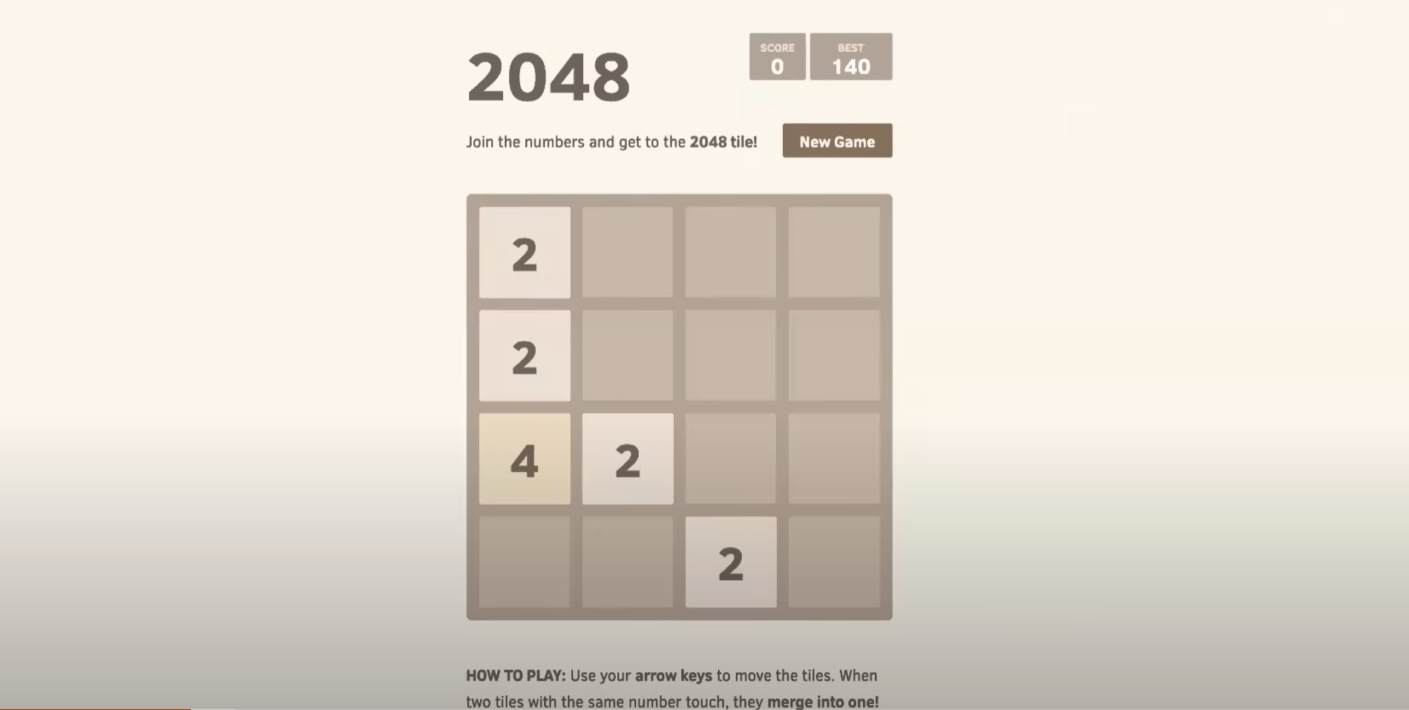We are going to deploy this application into our EKS Cluster.

Say, we have created 3 master and 2 worker nodes. We have our application in a pod in w2 node. We will create a pod and for that pod we will create service. Ususally they will have ClusterIP as a service but we will also have NodePort and Load Balancer types of service as well. The whole cluster will be inside a Private VPC. The user should be able to access the application inside the Pod from external world. If you use Cluster IP mode allows access within the cluster only. Node Port mode allows access from any IP address within the cluster, but limited to the private subnet. But all the resources in the cluster should be assigned with Elastic IP. This will be very expensive if we have 1000s of Pods.

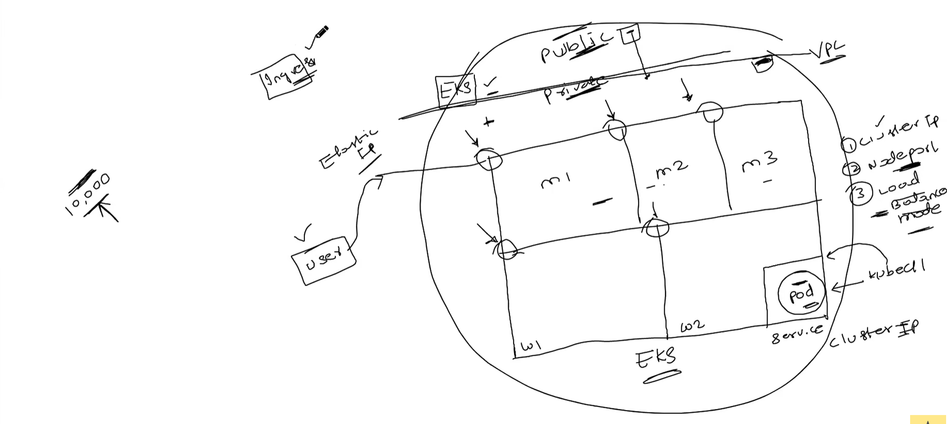That’s why we need to use Ingress. Ingress will be created on top of Service. Ingress Controller will look for Ingress getting requests. Ingress Controller will create Application load balancer which the user will access and it gets redirect to the Ingress and then to the Service and then to the Pod.

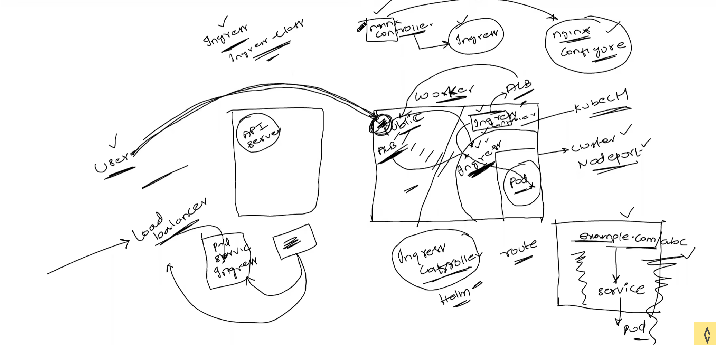We had lot of Ingress controllers in the market we choose any one of them. Example: NginX

**Repo:** <https://github.com/iam-veeramalla/aws-devops-zero-to-hero/tree/main/day-22>

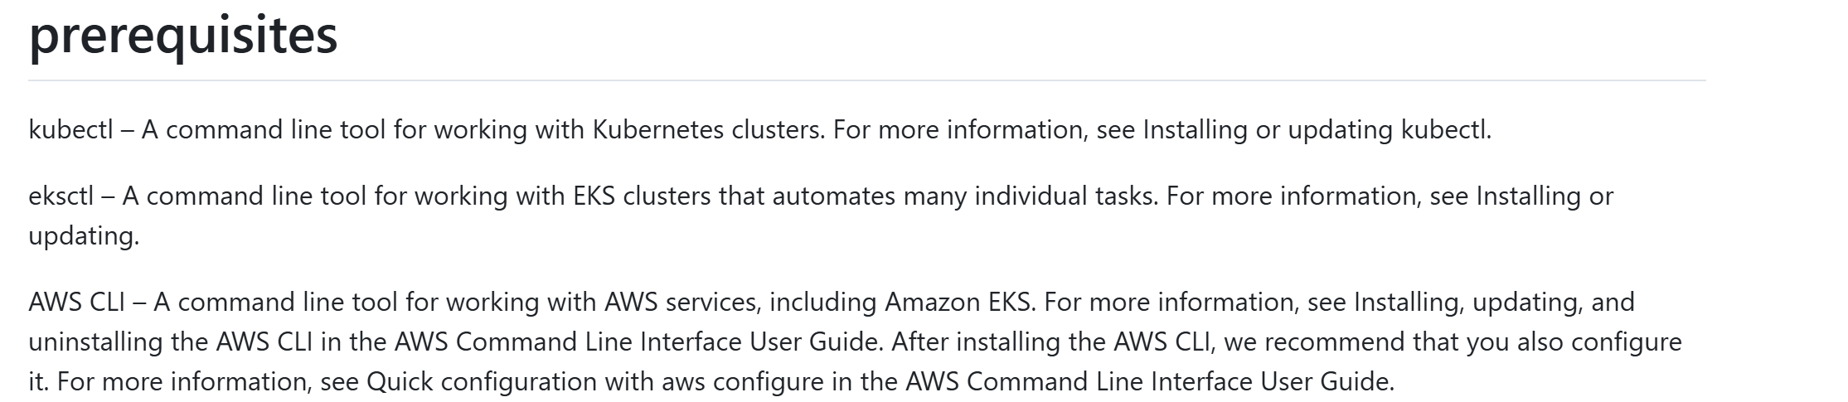

Take help from official documentations for installing these. EKSCTL is installed using ChatGPT and i-am-authentication is also required. Which is also installed with help of ChatGPT. Refer to GitHub Release pages for both.

We can create Cluster using EKS service in AWS but we need to provide a lot of information while creating it. But also, we can create using EKSCTL (Command line utility that is used to manage EKS Cluster).

For this project we are directly using Root account of AWS because if we want to user a separate user then we need to create IAM roles and add lot of permissions.

Let’s create Cluster using EKSCTL. It is useful for Create, get, list and delete clusters

* Create, drain and delete node groups
* Scale a node group
* Update a cluster
* Use custom AMIs
* Configure VPC Networking
* Configure access to API endpoints
* Support for GPU nodegroups
* Spot instances and mixed instances
* IAM Management and Add-on Policies
* List cluster CloudFormation stacks
* Install coredns
* Write kubeconfig file for a cluster

**CMD to Create EKS Cluster:** eksctl create cluster --name demo-cluster --region us-east-1 –fargate

We are using fargate for worker nodes. 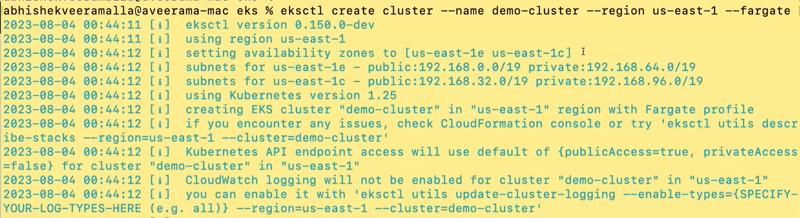It creates everuthing for us that is required to create EKS using AWS console. It creates public and private subnets and the application will be inside th private subnets.

It will 15 – 20 mins for creating EKS Cluster. Wait for control plane to get ready.

Switch to us-east-1 region in AWS console: 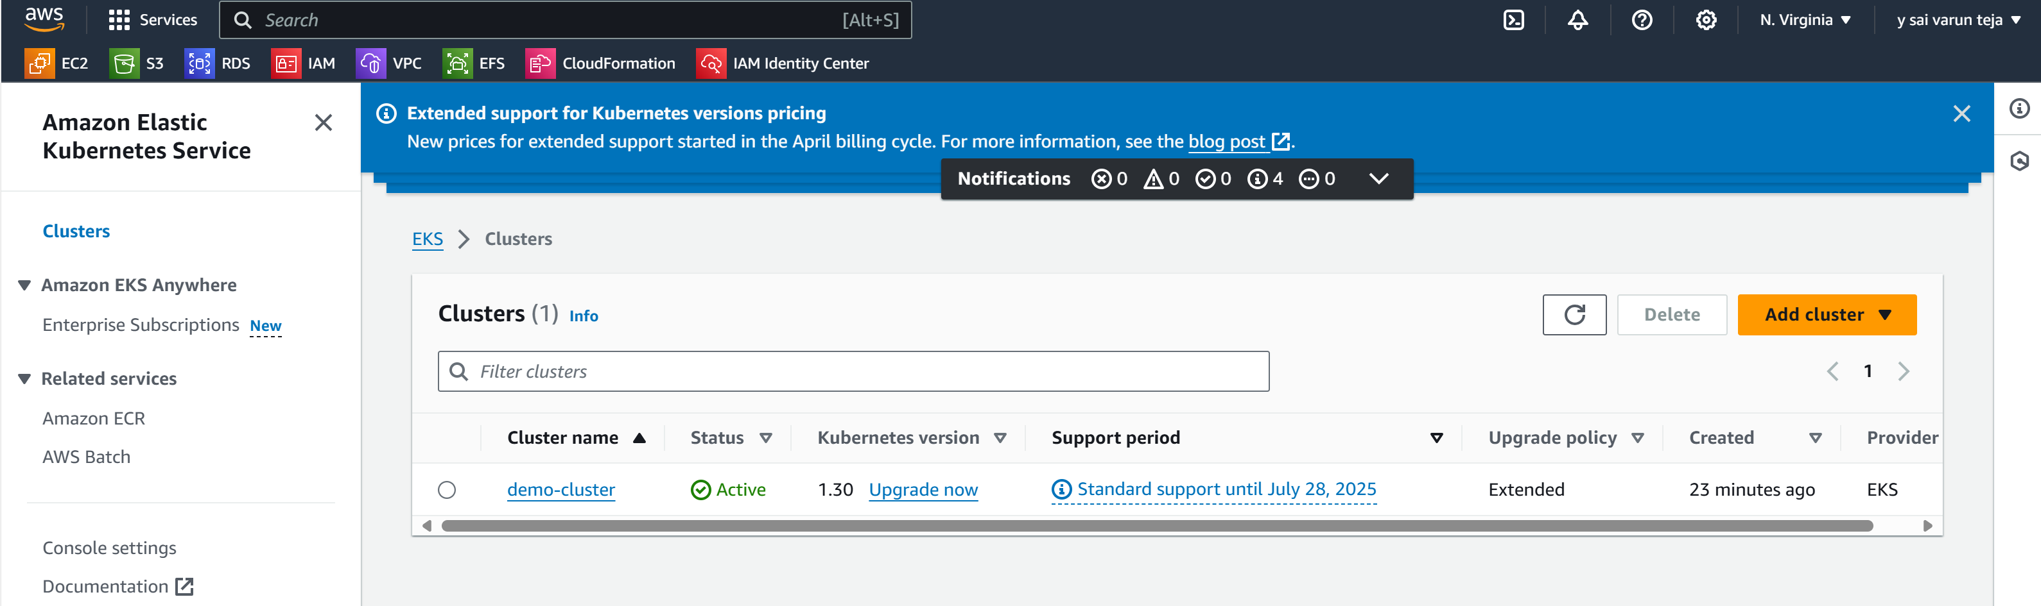Open the cluster, you can see the all the details about the cluster.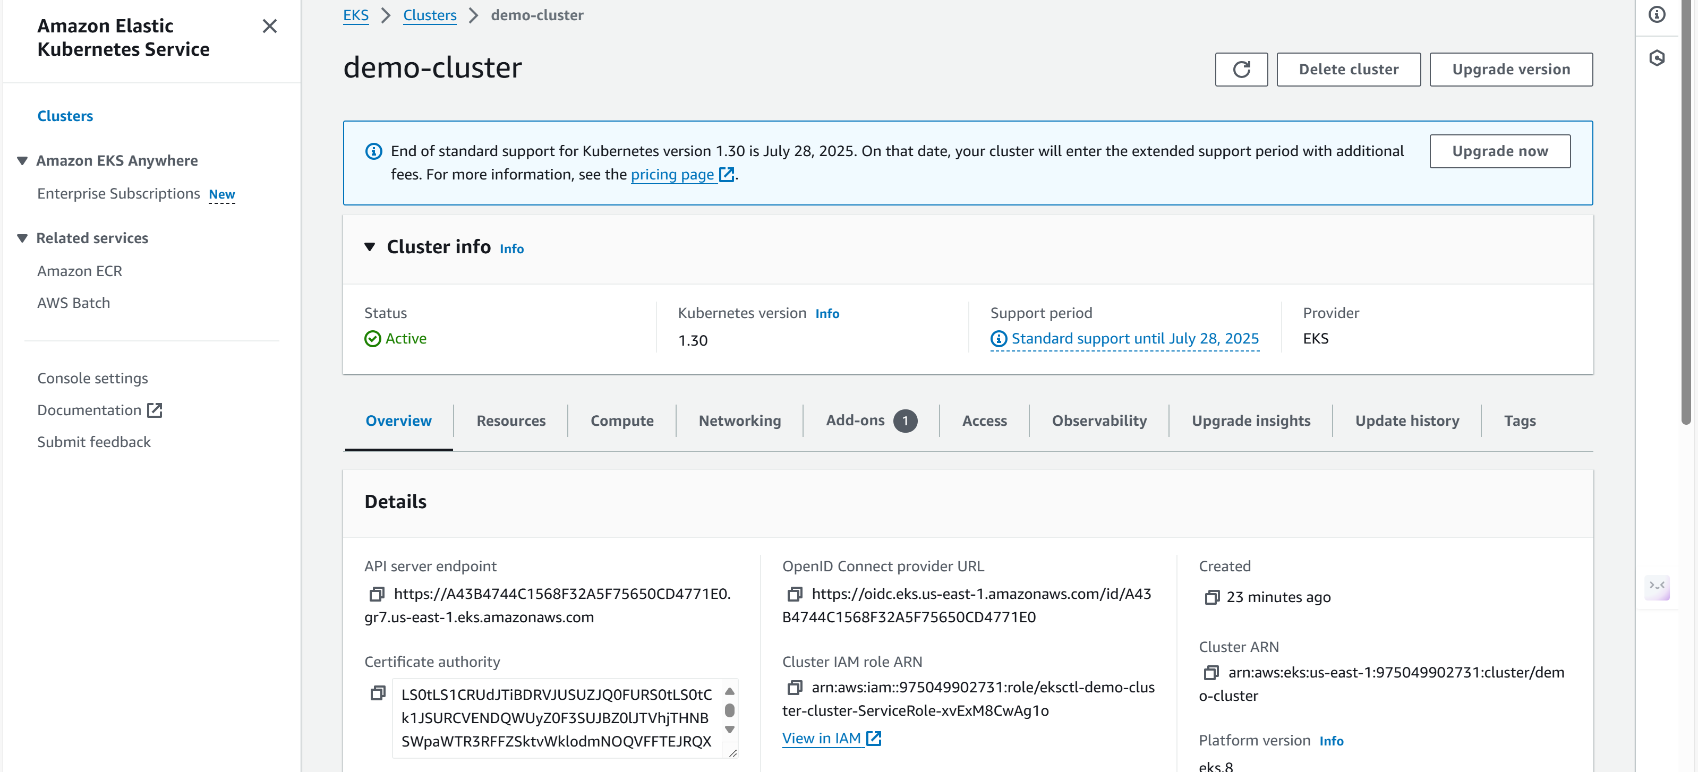We can check the resources available in our cluster. We no need to give any commands in the CLI.

We have to integrate an authentication method to our Cluster. We can assign IAM or any other as well. Whenever an resource in the cluster wants to talk with resource in the EKS we need to have an authentication. To K8s Pods we can attach or integrate IAM rules with k8s service accounts. So that, we can talk to any other AWS Services.

Under Compute section we can see Fargate profile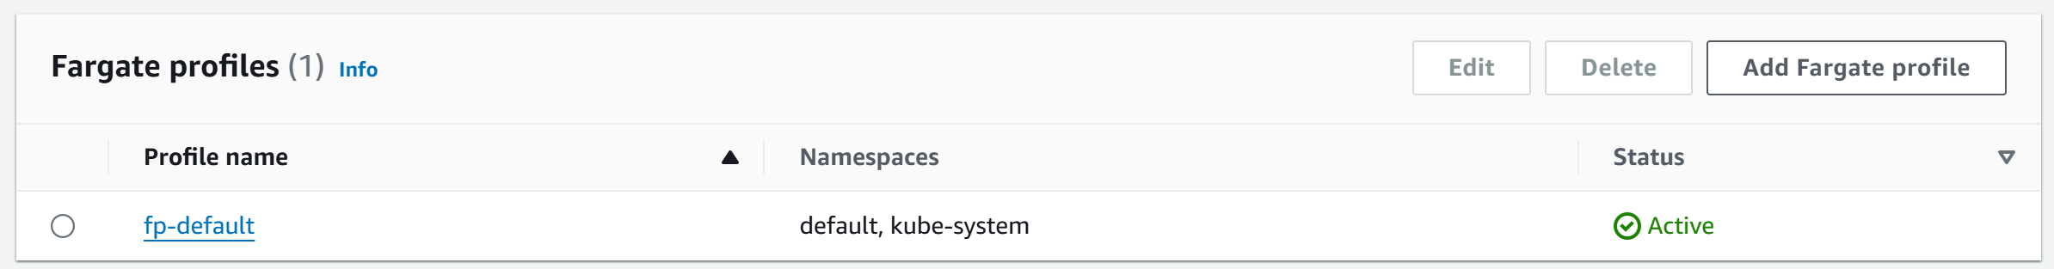

This is very imporrtant. If we want to deploy pods to any namespace it is not possible. We can deploy to default or kube-system name spaces only. If we wnt to deploy to different namespace then we have to create a new fargate profile.



Let’s try to deploy the actual 2048 application.

**URL:** [**https://github.com/iam-veeramalla/aws-devops-zero-to-hero/blob/main/day-22/2048-app-deploy-ingress.md**](https://github.com/iam-veeramalla/aws-devops-zero-to-hero/blob/main/day-22/2048-app-deploy-ingress.md)

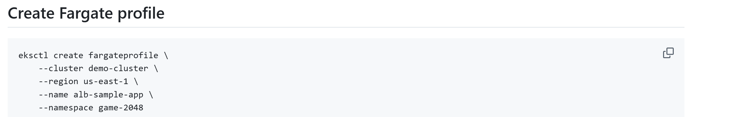We are adding a namespace for fargate as well here.**** New fargate is created with new namespace.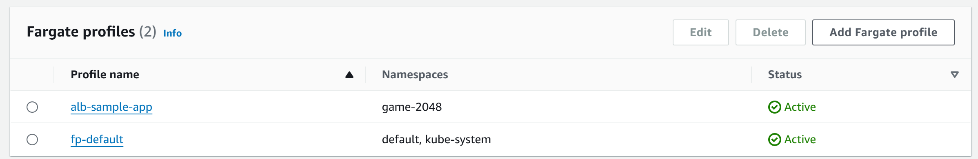 Now, 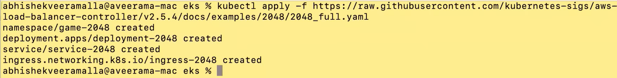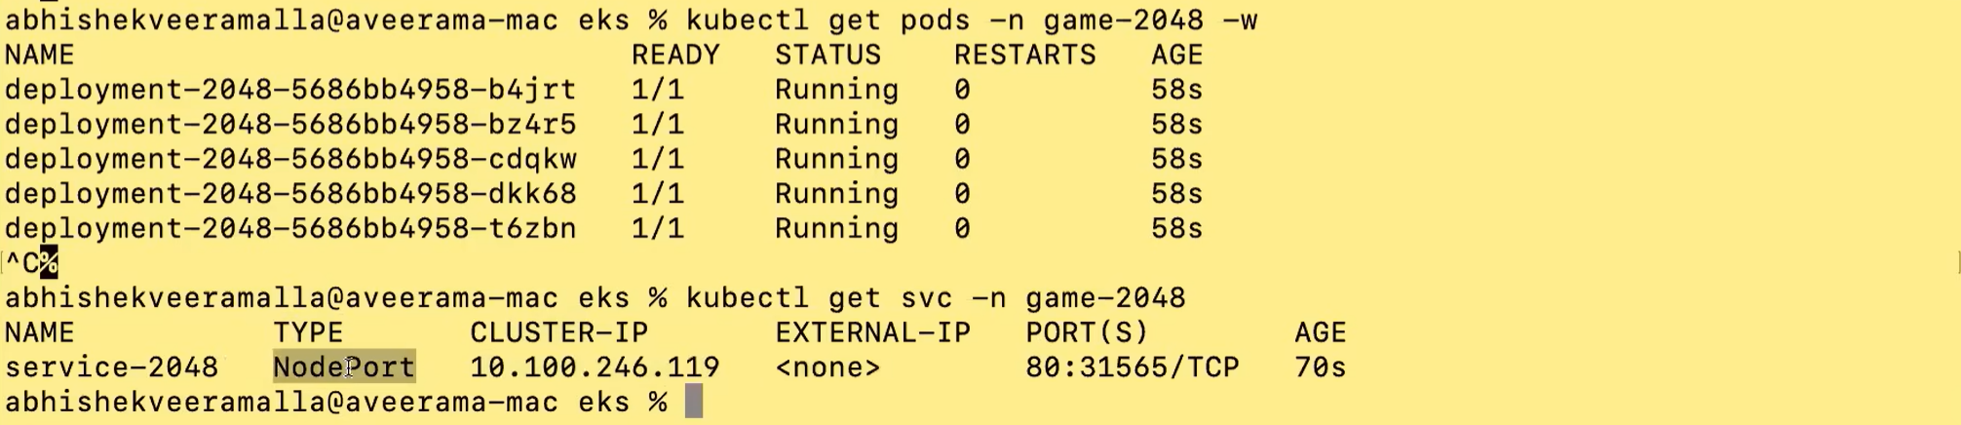We don’t have the External IP. Means anyone within the AWS VPC or who had access to the VPC can talk to this pod using the Node IP address following by Port number.

Our goal is to make this app available to the outside world. For that we have to create an Ingress. Ingress is already created. There is no address here for ingress. We need to create an Ingress controller also. Then we will get that address. We have to use this address to access the application form the outside world.

We will create an Ingress controller now, then it will read the Ingress resource called ingress-2048 and then it will create Load balancer.

We have to deploy the Ingress controller called as Application Load balancer.

Alb Controller (nothing but a K8s pod) needs to access/talk the application load balancer. So, we need to configure IAM OIDC provider.

**URL:** [**https://github.com/iam-veeramalla/aws-devops-zero-to-hero/blob/main/day-22/configure-oidc-connector.md**](https://github.com/iam-veeramalla/aws-devops-zero-to-hero/blob/main/day-22/configure-oidc-connector.md)

 If it is asking for region then add --region us-east-1

ALB Controller will be created as a Pod and it should have access to AWS services such as ALB.

**URL:** [**https://github.com/iam-veeramalla/aws-devops-zero-to-hero/blob/main/day-22/alb-controller-add-on.md**](https://github.com/iam-veeramalla/aws-devops-zero-to-hero/blob/main/day-22/alb-controller-add-on.md) 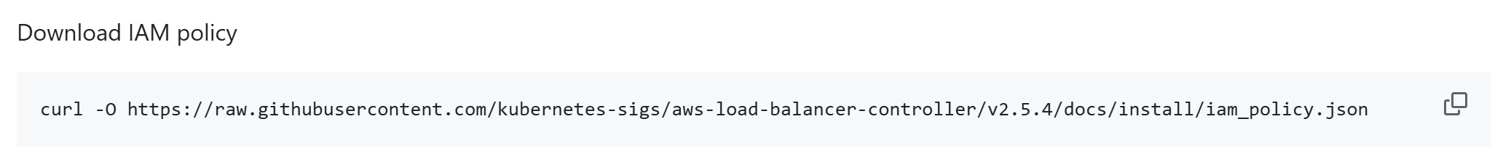  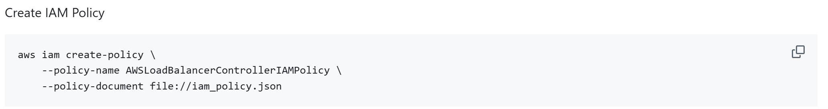 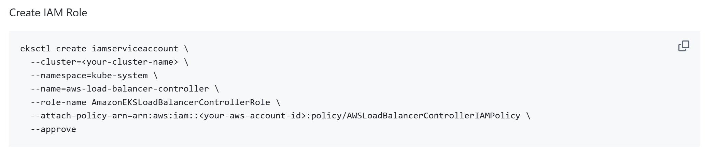Execute both commands. Then change the cluster name and aws-account ID in above pic. 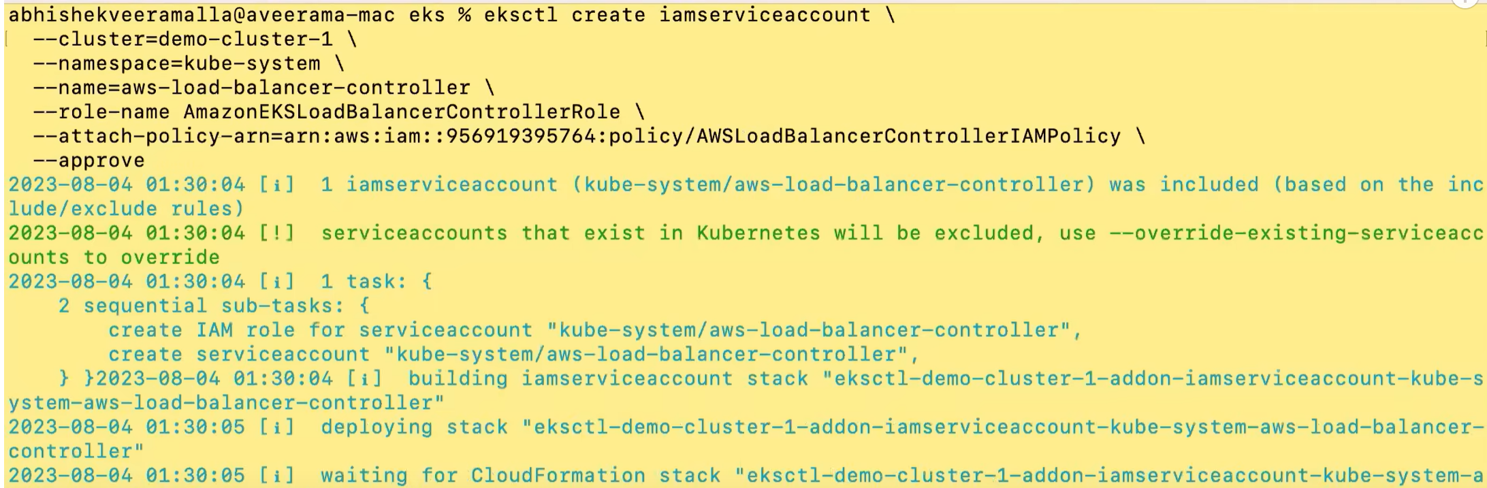If it is failed, try again. 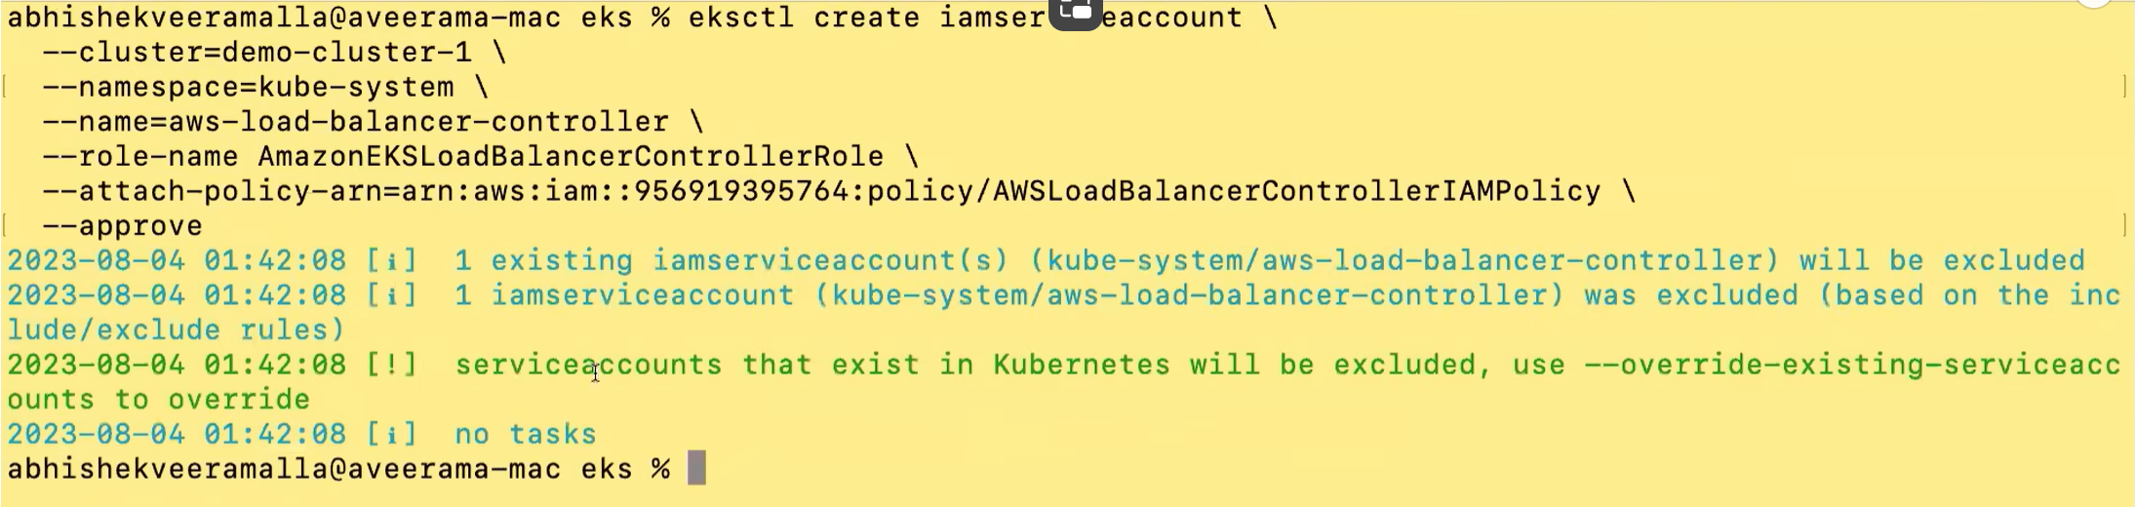We have to override now.

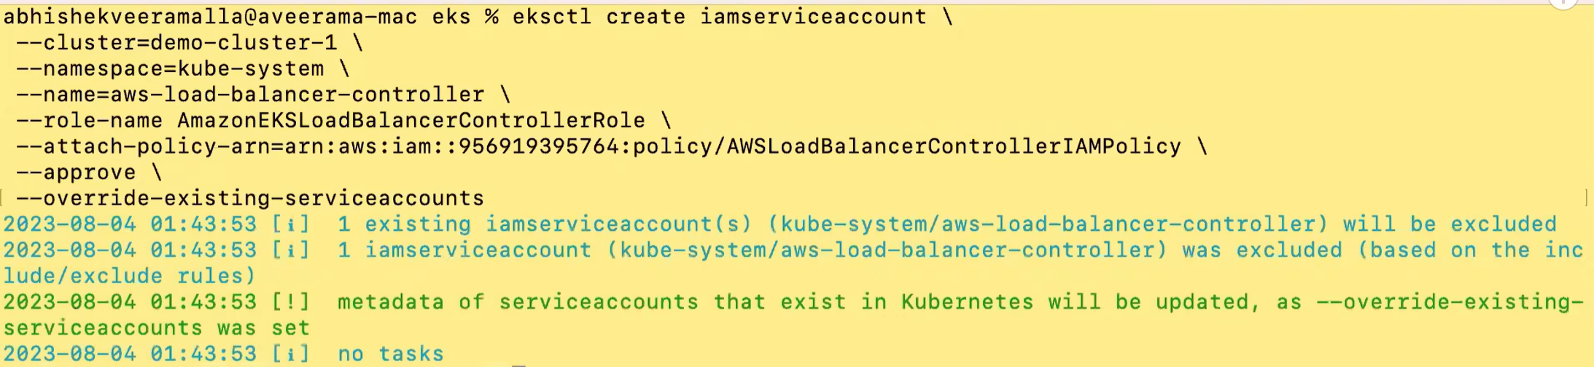

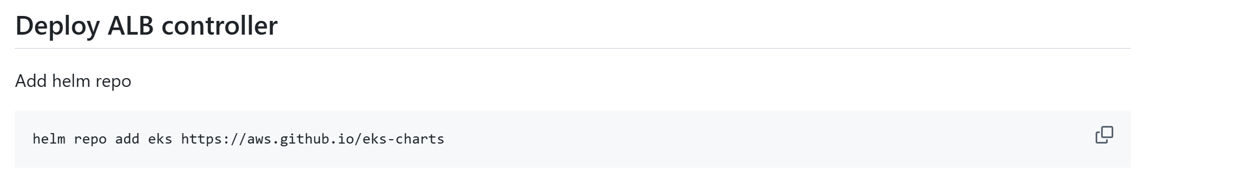

**Pre-Requsite:** Helm in PC.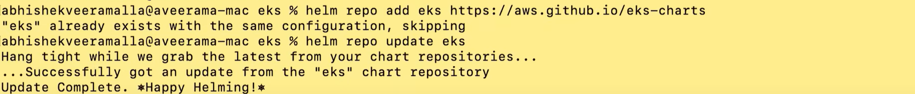

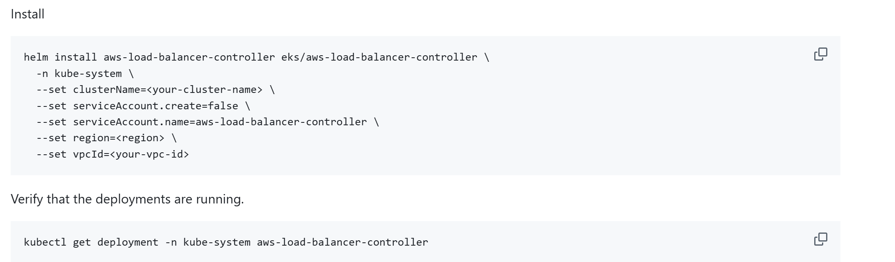 Give the VPC Id, Region, Cluster name.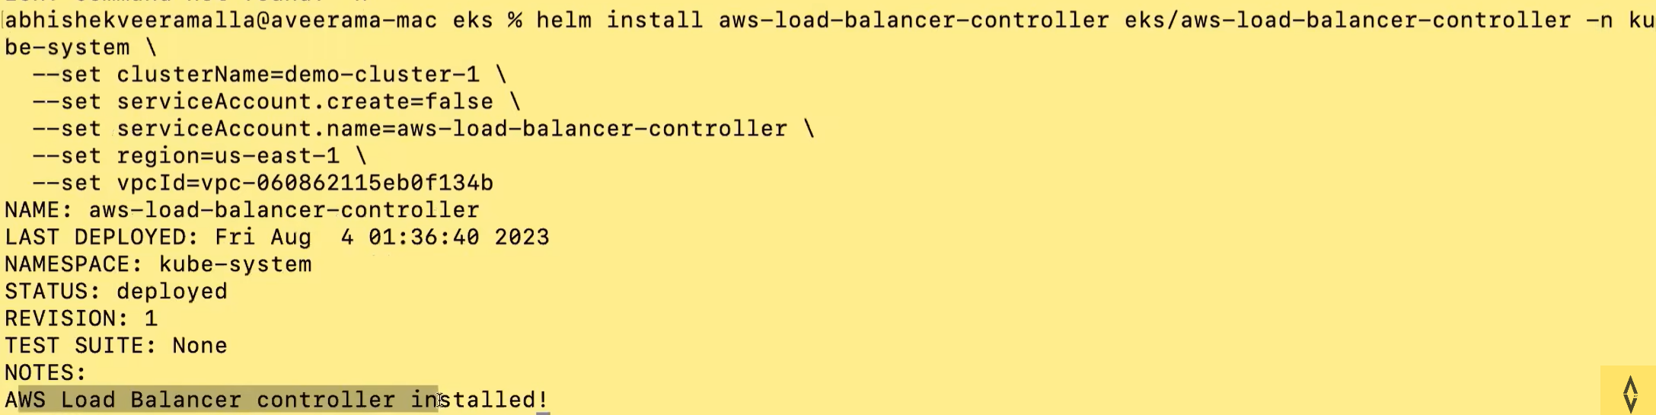Check the white spaces here for this command. Application load balancer is installed. 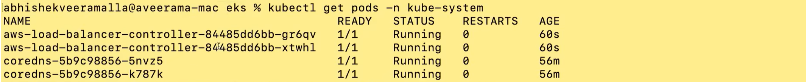   This application load balancer controller should create a ELB. 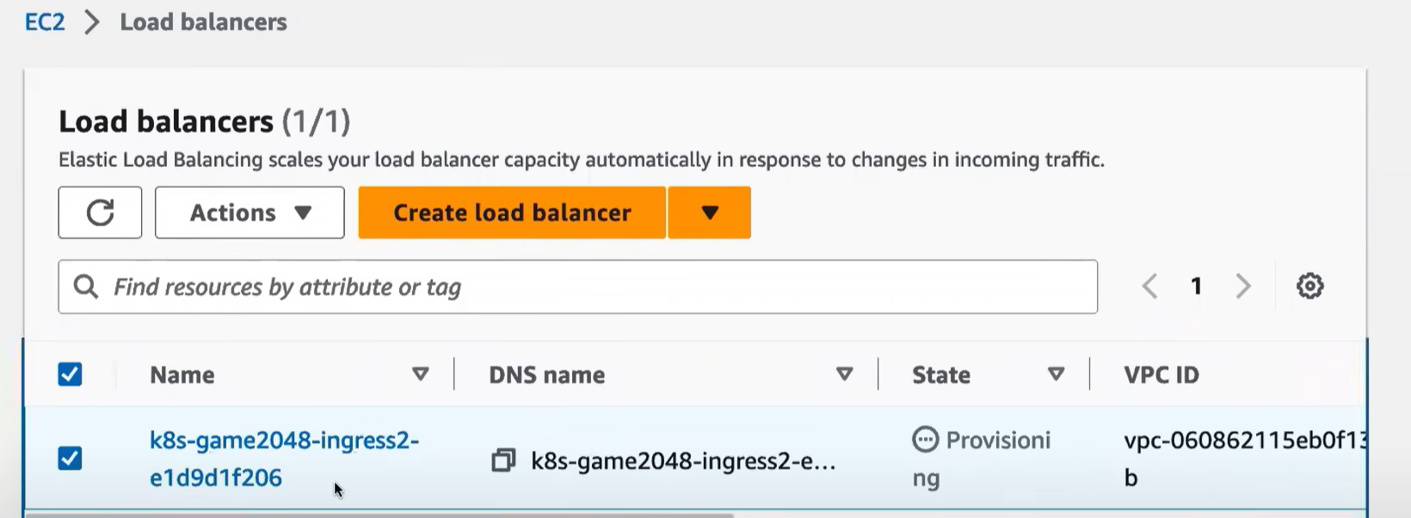Open it and you will find IP.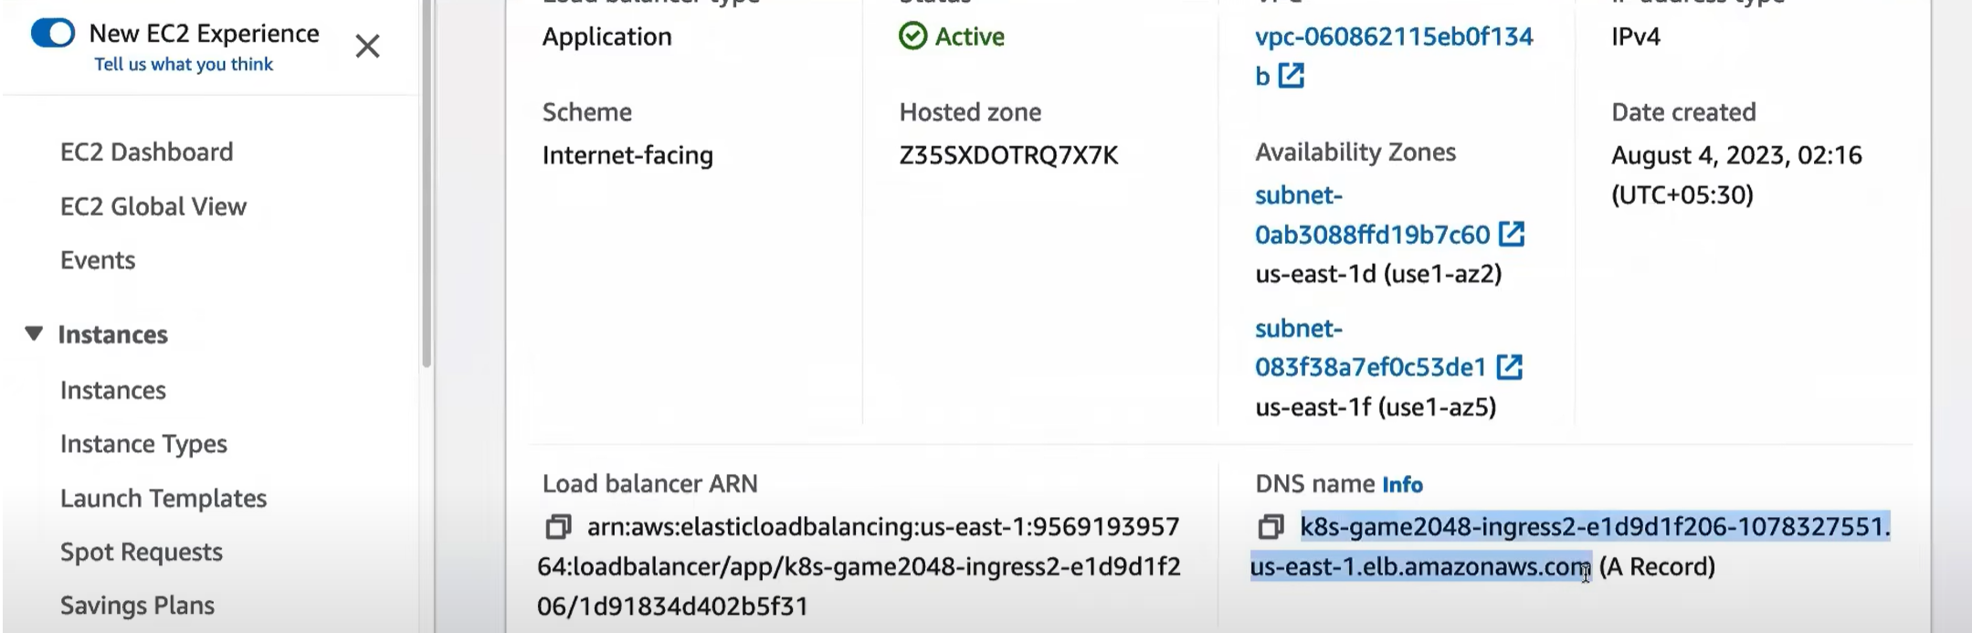  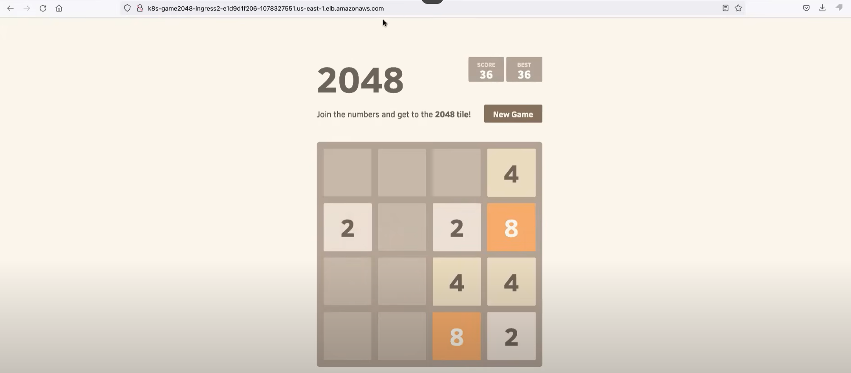

**To be deleted after finishing the demo:**

Delete EKS Cluster.

OIDC provider

IAM Policy

IAM Role

Cloudformation stacks

EC2 Load Balancer

Elastic IP

IAM Service Account